
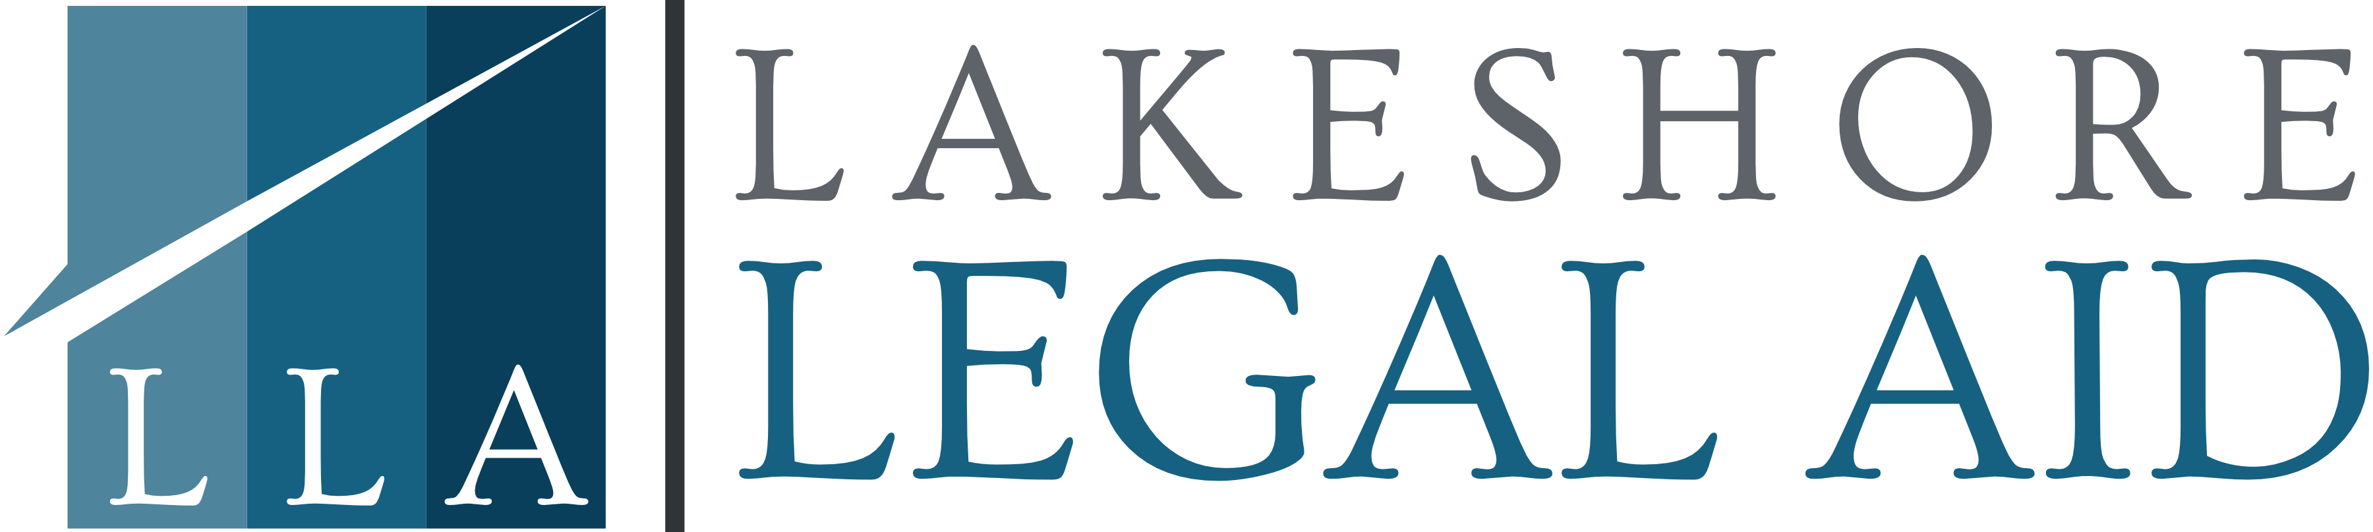

Apply for assistance online at:
www.michigan.gov/mibridges

For details on applying, please visit:
http://www.macombhomelesscoalition.com

Or Call: 586-213-5761

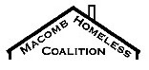

If you need wifi access to apply for benefits or for a zoom hearing a hotspot is located at:
xx

Lakeshore Legal Aid hotline

(888) 783-8190
Apply online at michiganlegalhelp.org.
If you need help paying your rent or if you need financial help to move, contact the following agencies as soon as possible:
The XXth District Court cannot provide advice or representation.
Free legal services are available:
A case has been or could be filed in the XXth District Court that could result in your eviction. The claims that have been made and the date and time to appear in court are in the attached documents.
Your landlord, or the party bringing this case against you, says you should be evicted.
You have the right to raise defenses and you have the right to be represented by an attorney. You may be eligible for assistance in paying your rent.
Assistance programs have different eligibility requirements. Contact the below organizations as soon possible if you need help.

HOW TO GET

LEGAL AND SOCIAL

Services Help

The XXth
District Court

